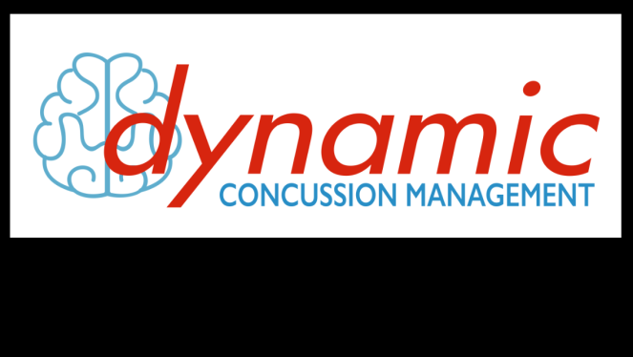
Base Line Testing Clinics

As a follow up to Dr. Craig Coghlin’s presentation at the 2014-2015 Banquet, the BBMHA Executive is strongly encouraging all the members to have their baseline testing done prior to the upcoming hockey season. We are currently hosting 2 clinics at the Brussels Library on the following dates. It is first come first served.

Dates: Sunday, September 27 Starting at 6:30pm
and if needed..........
Wednesday, September 30 Starting at 6:30pm
(Testing will take up to 1 hour and 20 min.)
Cost: $55/person
Cheques payable to: BBMHA
****Individual Receipts will be given from Dynamic Health & Rehabilitation that can be submitted to workplace insurance plans for reimbursement if requested at the time of payment.***

Assessor: Dr. Craig Coghlin,
Dynamic Health & Rehabilitation/Dynamic Concussion Management
www.DynamicHealthRehab.ca

Book your appointment with Liz Roth (Risk Management) via email at riskmanagement@blythbrusselsminorhockey.ca by
Thursday, September 24th

